**Session-8 Assignment**

**Name:-** Aryan Dilipbhai Langhanoja

**Enroll No:-** 92200133030

**AIM**: To understand VI characteristics and applications of Varactor diode, Tunnel Diode, Step recovery Diode and Schottky Diode.

**Objective:**

1. To understand working principle and structure of Varactor diode, Tunnel Diode, Step recovery Diode and Schottky Diode.
2. To understand application of Varactor diode, Tunnel Diode, Step recovery Diode and Schottky Diode.

**Apparatus:**

1. DC power Supply
2. Varactor diode
3. Tunnel Diode
4. Step recovery Diode
5. Schottky Diode
6. PN junction diode

**Task-1 Application of various diodes**

|  |  |  |
| --- | --- | --- |
| **Sr. No.** | **Diode** | **Applications** |
| 1 | Varactor diode | RF design arena,microwave systems, |
| 2 | Tunnel Diode | Tunnel diode can be used asa switch, amplifier, andoscillator. |
| 3 | Step recovery Diode | The step recovery diode is used as a parametric amplifier or pulse generator |
| 4 | Schottky Diode | Schottky diodes are used for their low turn-on voltage, fast recovery time and low-loss energy at higher frequencies. |

**Task-2 Compare outputs of pn junction diode and Schottky Diode at 60, 6000 and 60,000 Hz sinusoidal signal supply with 10V rms.**

**Sample Circuit diagram:**

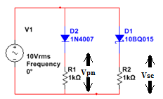

**Simulation circuit in Multisim:**

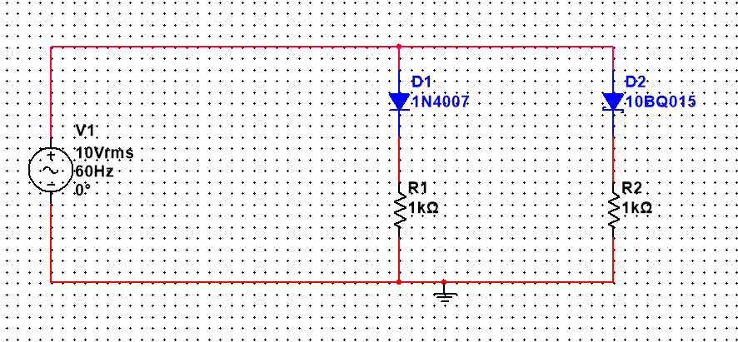

**Output waveforms at 60 Hz :**

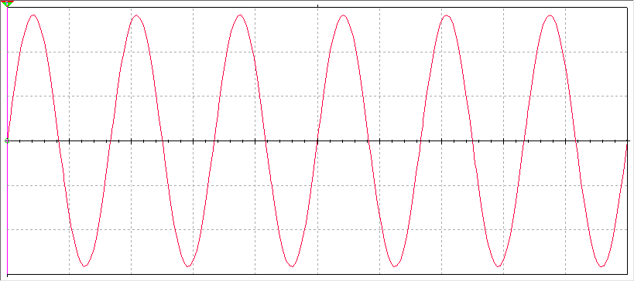

**Output waveforms at 6000 Hz**

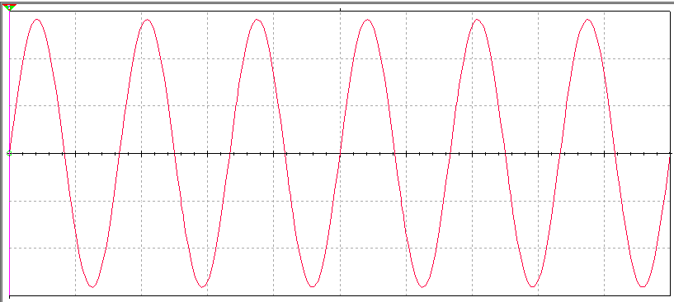

**Output waveforms at 60,000 Hz:**

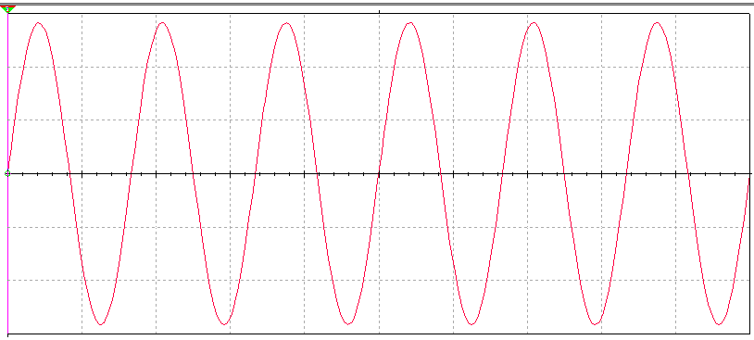

**Conclusion:**